

***Software Development Tools and Practices***

***PUSL2020***

***Coursework***

***2022–2023***

Term: Term 2

Submission Deadline: TBA

Coursework Type: Group Assignment

Element of Assessment: C1

Module Leader: Dr. Rasika Ranaweera | Ms. Pavithra Subhashini

E-mail: [ranaweera.r@nsbm.lk](mailto:ranaweera.r@nsbm.lk) | [pavithras@nsbm.ac.lk](mailto:pavithras@nsbm.ac.lk)

# Coursework

This coursework for PUSL2020 is worth 50% of the module marks. It is made up of two parts (i) a software product and (ii) a report containing your testing strategies and implementation. Students must create their own groups, up to a maximum of six group members. Each group must then decide and agree upon which technology they will use as well as specifying and allocating individual roles, and responsibilities.

# Project Scenario

NSBM Green University is planning to launch a web site to help the new students to find accommodation around the campus under the guidance of the new warden.

* The registered landlords/rental agencies can take picture(s) of their properties, explain the available facilities, set the location, rental, and advertise through the newly developed web application.
* The warden can view all the advertisements (as shown in Figure 1), validate by looking at the uploaded photo(s), and approve or reject stating a reason.
* The students can see the accommodations on a map and explore more details about the place and eventually rent the place through the website.
* The landlords should be notified when a reservation is requested, and they can either accept or deny the offer.

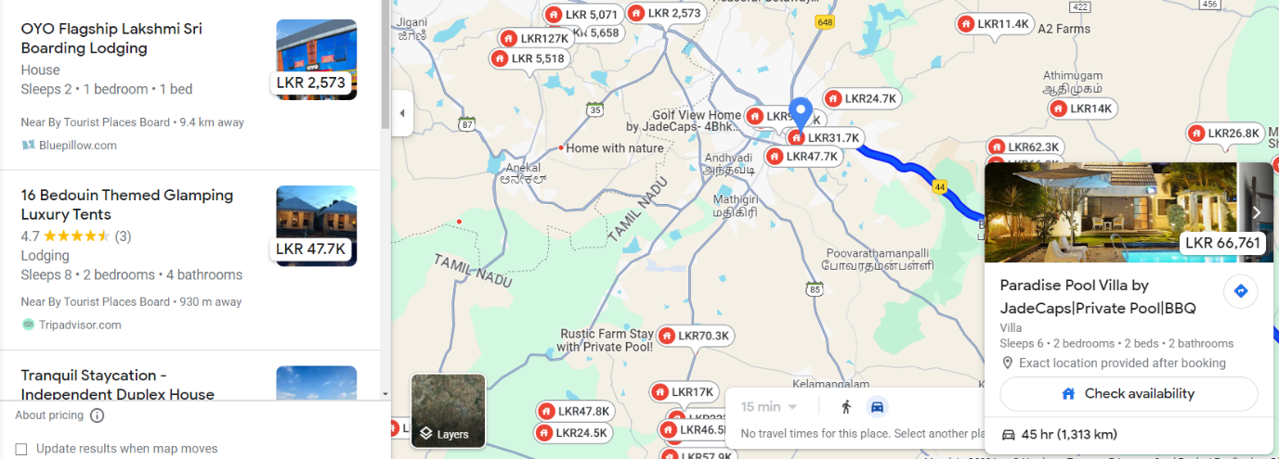

Figure 1. Sample GUI where the warden can see all the advertisements as a list and a map.

# Functional Requirements

Four types of users are to be supported: landlords, warden, students, and a Web Master (administrator).

* **Landlords**
  + Should be able to register and sign up for free.
  + Once registered, they can add data (including images), delete and update his/her own properties.
  + Can accept or reject the requests from the students
* **Warden**
  + Can see the advertisements posted by landlords as a list and on a map.
  + Should be able to select an individual property and view all the details (similar interface like the popup window in Figure 1).
  + Should be able to approve or reject an advertisement.
* **Students**
  + Should be able to browse the list of advertisements and check more details.
  + Should be able to reserve a property.
* **Web Master (Admin)**
  + Should be able to create accounts for the landlords, the warden, and the students.
  + Can also post articles to improve awareness about finding proper accommodations.

The system must store the user data and advertisements related data and the advertisements should be shown as an interface similar to the Figure 1. When a list item is selected, the relevant marker should be selected. When a maker is clicked on the map, a popup window should be displayed with more details about the property.

# Deliverables

There are two deliverables, and both should be submitted via DLE.

## Deliverable 1 [Development]

Create a web application using PHP or ASP.NET C# with MySQL/Oracle/SQL Server database or similar web technologies to demonstrate the above scenario while adhering to the given functional requirements.

## Deliverable 2 [Test and Report]

Write a comprehensive report comprising 2000 words explaining your testing strategies. The report should include:

* Evidence of your development (screenshots of all the pages along with a summary and the list of developers at the bottom of each screenshot)
* A description of the test cases you have designed
* A description of the structure and role of any mock objects you have used
* An explanation of how to run the unit tests and the integration tests
* Your functional test plans
* A critical analysis of your test strategy, explaining why you have tested the software in the way that you have.

# Detailed Assessment Criteria

|  |  |  |  |
| --- | --- | --- | --- |
| **Category and Weighting** | **Criteria** | **Marks** | **LOs** |
| Software Development  **50%** | * Application should satisfy all functional requirements. | 40 | LO1 |
| * Use of validations, pagination, and proper security measures. | 20 |
| * Application integrated appropriately with the database. | 10 |
| * Source code runs with test data. Data can be viewed, inserted, edited, and deleted from the database. | 30 |
| Testing and Reporting  **50%** | * Style of report is clear, professional and has a logically developed thread of argument throughout. | 20 | LO2  LO3  LO4 |
| * Unit tests and integration tests. | 30 |
| * Functional testing. | 20 |
| * Test and validation metrics (e.g., code coverage). | 10 |
| * Use of tools and techniques. | 10 |
| * One-page (per member) report explaining the individual contribution to the development and testing | 10 |

# Academic Offences

*See below for excerpt of Section AST10.2. Full details on the academic offences framework and procedures, consult Section AST10 is* [*available here.*](https://www.plymouth.ac.uk/uploads/production/document/path/8/8388/Section_D_Assessment.pdf)

Academic offences occur when activity is undertaken which could confer an unfair advantage to any candidate(s) in assessment. The University recognises the following (including any attempt to carry out the actions described) as academic offences, regardless of intent:

1. Copying or paraphrasing of other people’s work or ideas into a submitted assessment without full acknowledgement (plagiarism).
2. Unauthorised collaboration of students (or others) in a piece of work (collusion).
3. Making false declarations in an attempt to obtain either modified assessment provisions or special consideration (e.g. of extenuating circumstances).
4. Persuading another member of the University or partner institution (student, staff, or other) to participate in any way in actions which would be in breach of these regulations.
5. Misrepresenting research outcomes and results.
6. Being party to any arrangement which would constitute a breach of these regulations.
7. The inclusion in a piece of assessed work (other than an examination or test) of material which is identical or substantially similar to material which has already been submitted for any other assessment within the University.
8. Any other activity which could confer an unfair advantage to any candidate(s).

# Submission Type

The report should be a PDF (preferred) or Word document. A zip file containing project work and other assets should be uploaded to the Plymouth Digital Learning Environment (DLE).